**Fuzzy Controller for Quarter Car Active Suspension System**

# **Introduction**

Many studies are carried out to increase the driver comfort of cars. One of these comfort-providing efforts is the suspension systems of cars. In previous, passive suspension systems without control systems were trying to reduce the vibrations coming from the wheels or the oscillations occurring on bumps by dampening them. After that, active control systems were developed by adding a controller. Active control systems cannot yet meet the level of car safety and comfort demanding from customers. Many techniques developed for the controller used in active suspension systems are available in the literature. Fuzzy logic is one of them. Thanks to Fuzzy Logic's success in evaluating gray areas not only black and white (1-0), vibrations can be dampened more accurately and fast. The actuator controlled by the controller is placed in the car between the car body and the wheels. It ensures that the car body keeps still in the vertical axis or minimizes its movement by decreasing or increasing the distance between the car body and the wheel in the up and down movements of the wheels.

Since active suspension systems are complex and nonlinear systems, model-based control methods are not applicable. Therefore, fuzzy set-based control systems and nonlinear dynamic systems are more suitable and used. Many methods have been used in the literature for the active controller. These are PID (Proportional-Integral-Derivative) [X2], MPC (Model Predictive Control) [X1], LQG (Linear Quadratic Gaussian) [X3], H-infinity [X4], SMC (Sliding Mode Control) [X5] and Fuzzy [X6]. (Burdaki makale konularında biraz detay bilgilerin verilmesi.)

Studies in the literature have also carried out membership functions as triangular and trapezoidal. The value ranges were mostly determined equally. In this study, unlike the literature, Gaussian membership functions were used instead of triangular or trapezoidal in fuzzy control membership functions, and the value ranges were adjusted to provide optimum results. In this way, as shown in the paper, more comfort is provided than the comfort produced by other membership functions.

# **Mathematical Model of Suspension System**

A quarter car suspension system consists of one-fourth of car, sprung and damper total mass value. The system measuring vertical acceleration of car body and wheel has 2-DOF model. In active control system, there is control input to dampen the shock vibrations. There are many methods for active control systems. The main purpose of suspension control is to keep the car vertical acceleration at zero or minimize it.

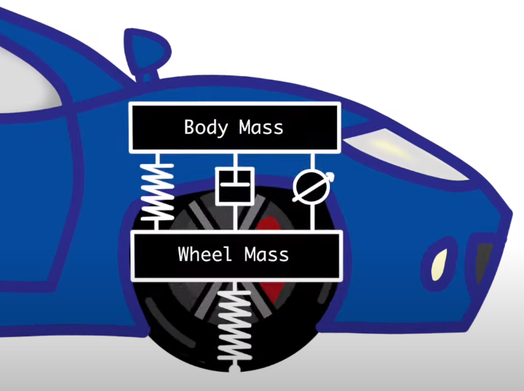Figure 1: Active control system for quarter car model. (Change the picture)

Figure 1 shows the plant model for car suspension model. In this model, there are car sprung, damper and control input unit, which are between car body and wheel, wheel sprung which is between wheel and road. The control input unit control the distance between car body and wheel.

Table 1: Parameter values used in proposed model.

|  |  |
| --- | --- |
| Parameter | Value |
| Sprung Mass ($m_{car}$) | 320 kg |
| Unsprung Mass ($m_{wheel}$) | 40 kg |
| Actuator Force ($u_{c}$) | 10,000 N |
| Stiffness of Damper ($k_{car}$) | 18,000 N/m |
| Stiffness of Tyre ($k_{wheel}$) | 200,000 N/m |
| Damping Coefficient of Damper ($c_{car}$) | 1000 N/m/s |

When the Newton’s second law is applied to the plant model showing in figure 1, the equations showing below can obtain.

$$\begin{aligned}{\overset{¨}{z}}_{car}=\frac{c_{car}\left({\overset{˙}{z}}_{wheel}-{\overset{˙}{z}}_{car}\right)+k_{car}\left(z_{wheel}-z_{car}\right)+uc}{m_{car}} \#\left( SEQ Equation \backslash * ARABIC 1\right)\end{aligned}$$

${\overset{¨}{z}}_{car}$ is acceleration on the car body. The main purpose is making ${\overset{¨}{z}}_{car}$ zero or minimize it. It depends on damper force, sprung force, and control input force. ${\overset{˙}{z}}_{car}$ is velocity of car body. ${\overset{˙}{z}}_{wheel}$ is velocity of wheel. $z_{car}$ is car body vertical position. $z_{wheel}$ is wheel vertical position.

$$\begin{aligned}{\overset{¨}{z}}_{wheel}=\frac{-c_{car}\left({\overset{˙}{z}}_{wheel}-{\overset{˙}{z}}_{car}\right)-k_{car}\left(z_{wheel}-z_{car}\right)+k_{wheel}\left(ud-z_{wheel}\right)-uc}{m_{wheel}} \#\left( SEQ Equation \backslash * ARABIC 2\right)\end{aligned}$$

${\overset{¨}{z}}_{wheel}$ is acceleration on the wheel. It depends on damper and sprung force between car body and wheel, sprung force between wheel and road and control input force.

The state space equation of the model showing in figure 1 is below. Hence this model has two inputs (control input and road disturbance), the state space equation is better.

$$\begin{aligned}\left[\begin{matrix}{\overset{˙}{z}}_{car} \\ {\overset{¨}{z}}_{car} \\ {\overset{˙}{z}}_{wheel} \\ {\overset{¨}{z}}_{wheel}\end{matrix}\right]=\left[\begin{matrix}0 & 1 & 0 & 0 \\ \frac{-k_{car}}{m_{car}} & \frac{-c_{car}}{m_{car}} & \frac{k_{car}}{m_{car}} & \frac{c_{car}}{m_{car}} \\ 0 & 0 & 0 & 1 \\ \frac{k_{car}}{m_{wheel}} & \frac{c_{car}}{m_{wheel}} & \frac{-\left(k_{car}+k_{wheel}\right)}{m_{wheel}} & \frac{-c_{car}}{m_{wheel}}\end{matrix}\right]*\left[\begin{matrix}z_{car} \\ {\overset{˙}{z}}_{car} \\ z_{wheel} \\ {\overset{˙}{z}}_{wheel}\end{matrix}\right]+\left[\begin{matrix}0 & 0 \\ \frac{1}{m_{car}} & 0 \\ 0 & 0 \\ \frac{-1}{m_{wheel}} & \frac{k_{wheel}}{m_{wheel}}\end{matrix}\right]*\left[\begin{matrix}uc \\ ud\end{matrix}\right] \#\left( SEQ Equation \backslash * ARABIC 3\right)\end{aligned}$$

The state variables given in equations (3) illustrate the vertical movement of car body and the wheels. $k_{wheel}$ indicates the stiffness of sprung which take place between wheel and road. $k_{car}$ indicates the stiffness of sprung which take place between car body and wheel. $c_{car}$ indicates the damping coefficient of damper. $uc$ constitutes control force where takes place between car body and wheel. $ud$ states the road disturbance.

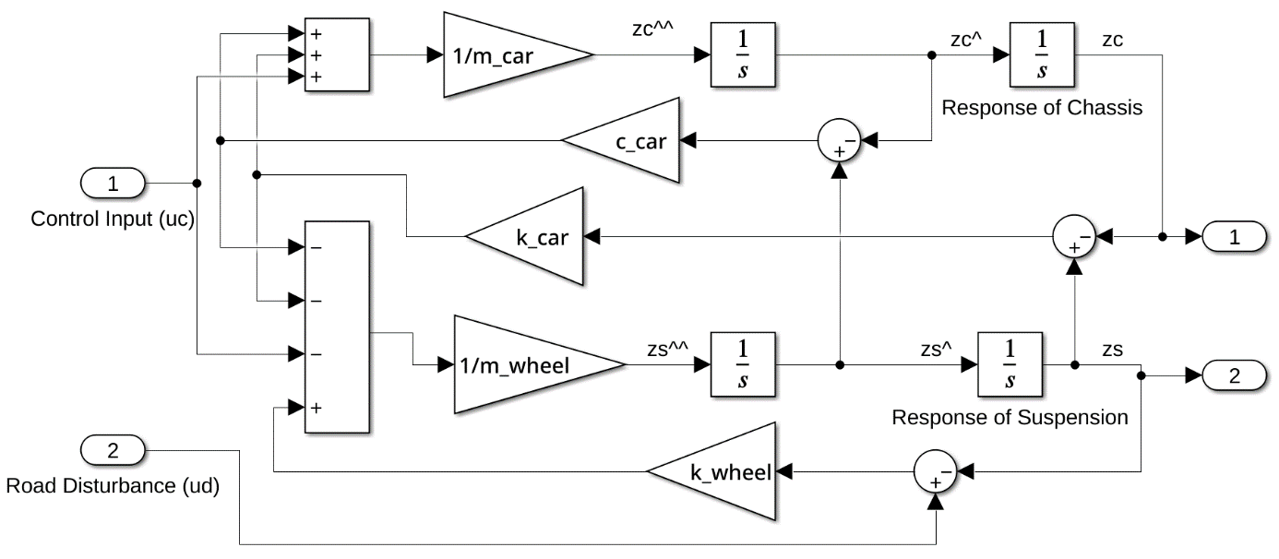

Figure 2: Mathematical model belonging to quarter car suspension system.

# **Fuzzy Controller Design**

The fuzzy logic controller has two inputs that are car body displacement $z_{car}$ and velocity ${\overset{˙}{z}}_{car}$. It has one output that is desired actuator force uc. The Fuzzy Logic Controller has three steps that fuzzification, fuzzy inference system (FIS) and defuzzification. The real values areconverted into fuzzy values in fuzzification step. FIS processes the fuzzy values and calculate output by using rules and data. The calculated output consists of fuzzy values. The output values convert into real values in defuzzification step.

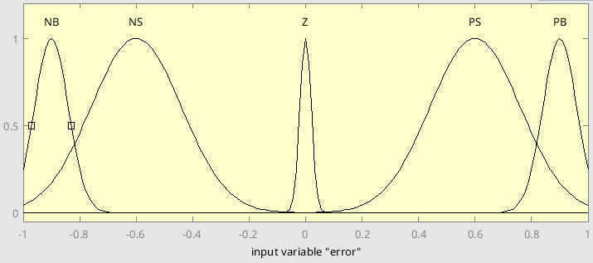

Figure 3: Membership function for “Error” input.

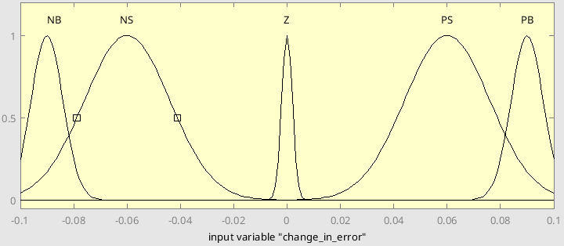

Figure 4: Membership function for “Change In Error” input.

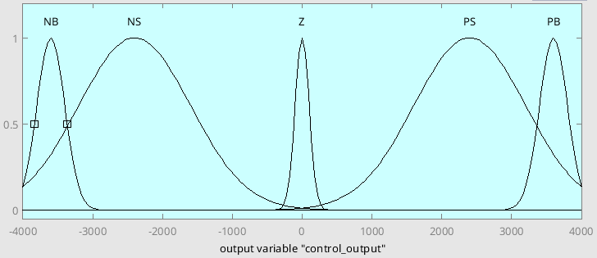

Figure 5: Membership function for “Actuator Force” output.

Table 2: Fuzzy logic rules table.

|  |  |  |  |  |  |
| --- | --- | --- | --- | --- | --- |
| e \ cE | NB | NS | Z | PS | PB |
| NB | NB | NB | NS | NS | Z |
| NS | NB | NS | NS | Z | PS |
| Z | NS | NS | Z | PS | PS |
| PS | NS | Z | PS | PS | PB |
| PB | Z | PS | PS | PB | PB |

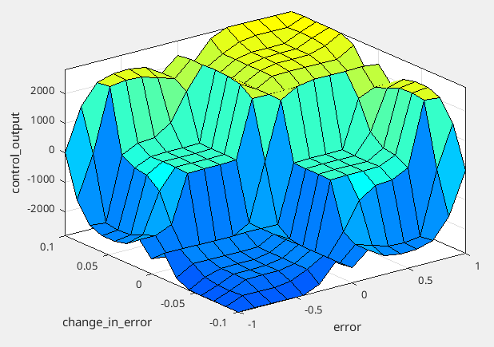

Figure 6: Fuzzy logic rules surface plot.

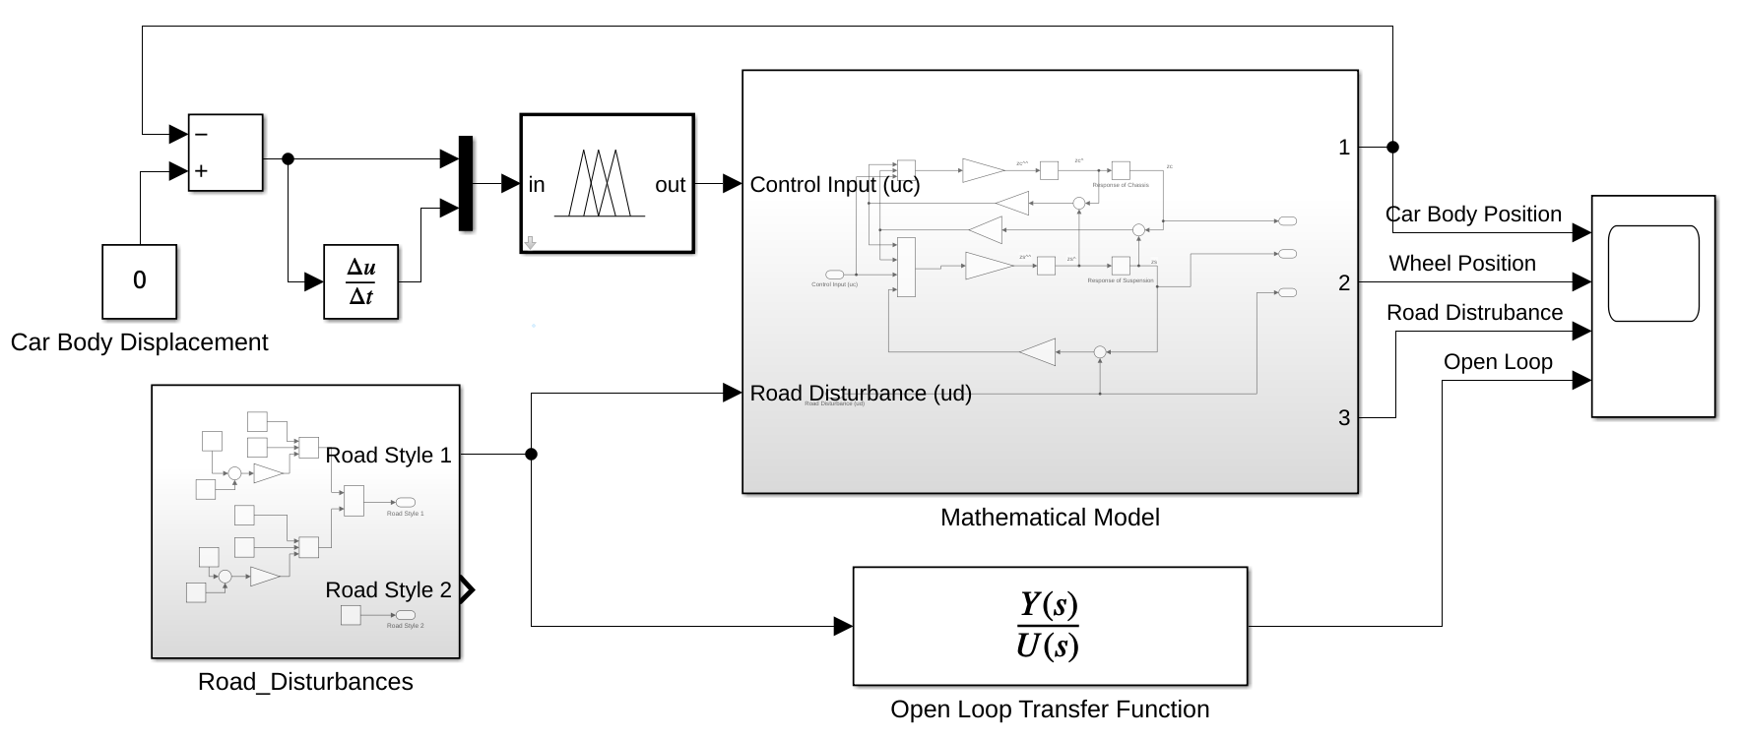

Figure 7: The block diagram of fuzzy logic control.

# **Simulation Results**

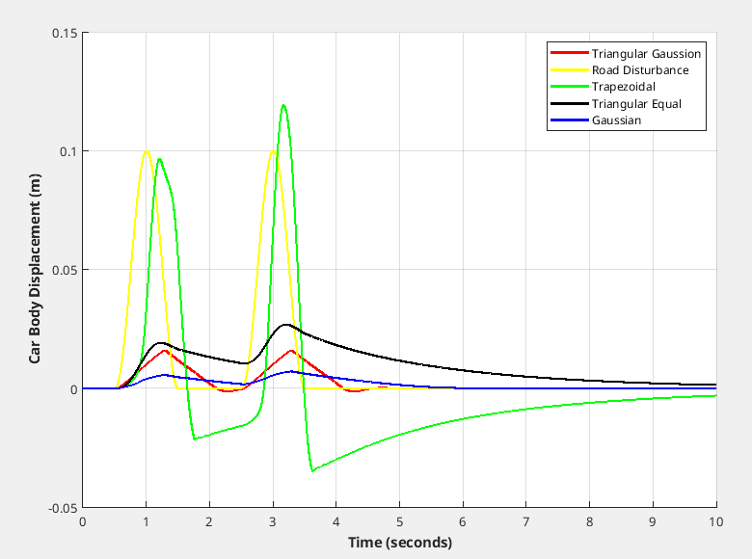

Figure 8: Car body displacement for first road profile.

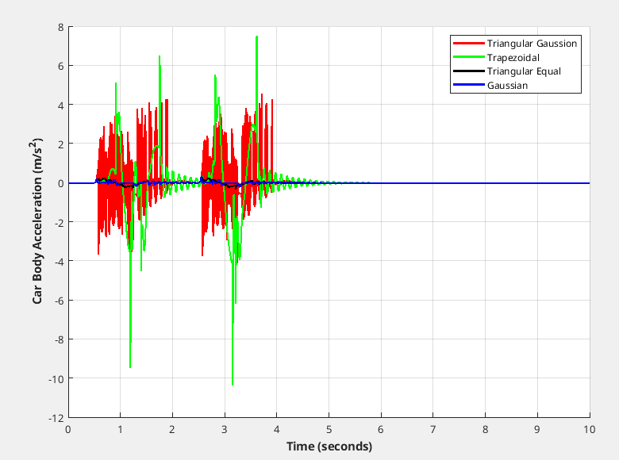

Figure 9: Car body acceleration for first road profile.

To make generalize the proposed the function success,

Table 3: Compare the membership function achieve rate for road profile 1.

|  |  |  |  |
| --- | --- | --- | --- |
| Membership Function | Success Criteria ($mm$) | | |
| RMS | Max | Mean |
| Triangular Gaussian | 5.241 | 15.93 | 2.465 |
| Trapezoidal | 30.65 | 119.2 | -1.068 |
| Triangular Equal | 11.83 | 26.88 | 9.454 |
| Gaussian | 2.818 | 7.214 | 1.802 |

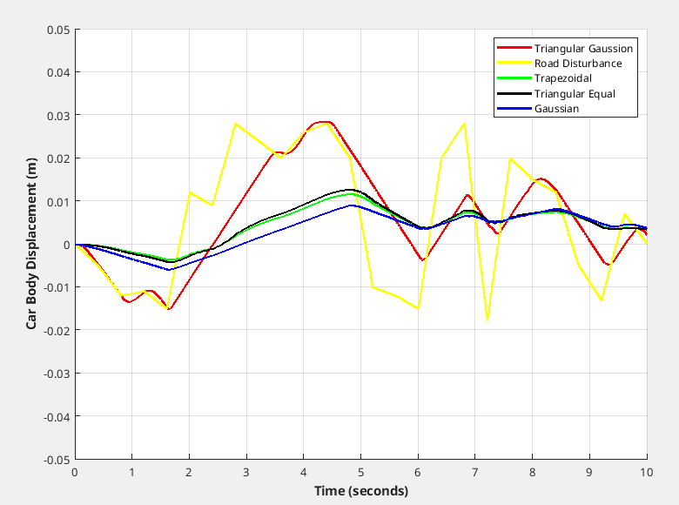

Figure 10: Car body displacement for second road profile.

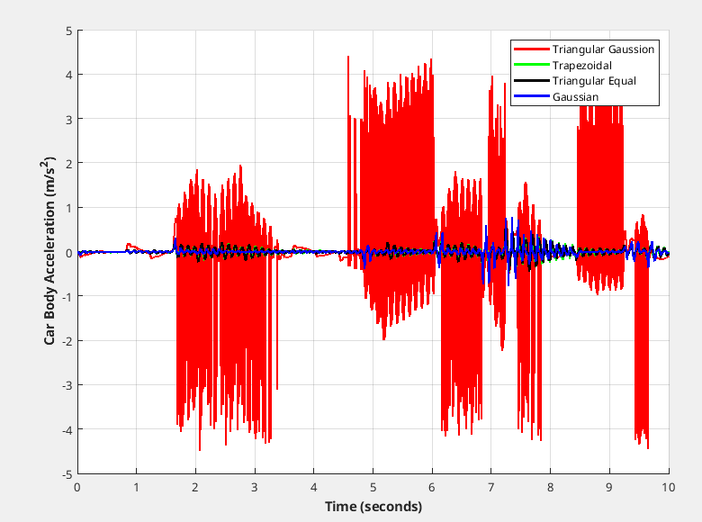

Figure 11: Car body acceleration for second road profile.

Table 4: Compare the membership function achieve rate for road profile 2.

|  |  |  |  |
| --- | --- | --- | --- |
| Membership Function | Success Criteria ($mm$) | | |
| RMS | Max | Mean |
| Triangular Gaussian | 12.76 | 28.40 | 5.576 |
| Trapezoidal | 11.65 | 4.233 | 5.921 |
| Triangular Equal | 6.335 | 12.73 | 4.448 |
| Gaussian | 5.293 | 9.107 | 3.068 |

# **Conclusion**

# **References**

[X1] Bououden, S. & Chadli, M. & Karimi, Hamid. (2015). A Robust Predictive Control Design for Nonlinear Active Suspension Systems. Asian Journal of Control. 18. 10.1002/asjc.1180.

[X2] Sharkawy, Abdel-Nasser & Ali, Ahmed & Ghazaly, Nouby & Abdel-Jaber, Gamal. (2015). PID CONTROLLER OF ACTIVE SUSPENSION SYSTEM FOR A QUARTER CAR MODEL. International Journal of Advances in Engineering & Technology. Vol. 8. 899-909.

[X3] Elmadany, Mohamed & Abduljabbar, Zuhair & Professor, Associate. (1999). Linear Quadratic Gaussian Control of a Quarter-Car Suspension. Vehicle System Dynamics - VEH SYST DYN. 32. 10.1076/vesd.32.6.479.4224.

[X4] Fallah, Saber & Bhat, Rama & Xie, Wen-Fang. (2009). H(infinity) Robust Control of Active Suspensions: A Practical Point of View. Proceedings of the American Control Conference. 1385 - 1390. 10.1109/ACC.2009.5160098.

[X5] Deshpande, Vaijayanti & Bhaskara, Mohan & Phadke, Shrivijay. (2012). Disturbance observer based sliding mode control of active suspension systems. Journal of Sound and Vibration. 333. 70-75. 10.1109/VSS.2012.6163480.

[X6] Palanisamy, Senthilkumar & Karuppan, Sivakumar. (2016). Fuzzy control of active suspension system. Journal of Vibroengineering. 18. 3197-3204. 10.21595/jve.2016.16699.